**E211 – Operations Planning II**

**Additional Questions for Operations Planning II Workshop (3rd Dec 2018)**

**Question 1**

Table below shows a partial Holt’s method used to forecast sales based on Alpha = 0.4 and Beta = 0.3.

|  |  |  |  |  |
| --- | --- | --- | --- | --- |
| Period | Sales (Ton) | Level | Trend | Forecast |
| … | … | … | … | … |
| 4 | 84 | 84.784 | -0.736 | 85.306 |
| 5 | 79 | 82.029 | -1.342 | 84.048 |
| 6 | 80 |  |  |  |

1. Calculate:

* Level for 6th period
* Trend for 6th period
* Forecast for 7th period
* Forecast for 11th period

1. When is Holt’s method more suitable to be used to do the forecast than the linear regression method?

**Question 2**

The following table shows the application of multiplicative decomposition method used to do forecast based on quarterly data for the past four years.

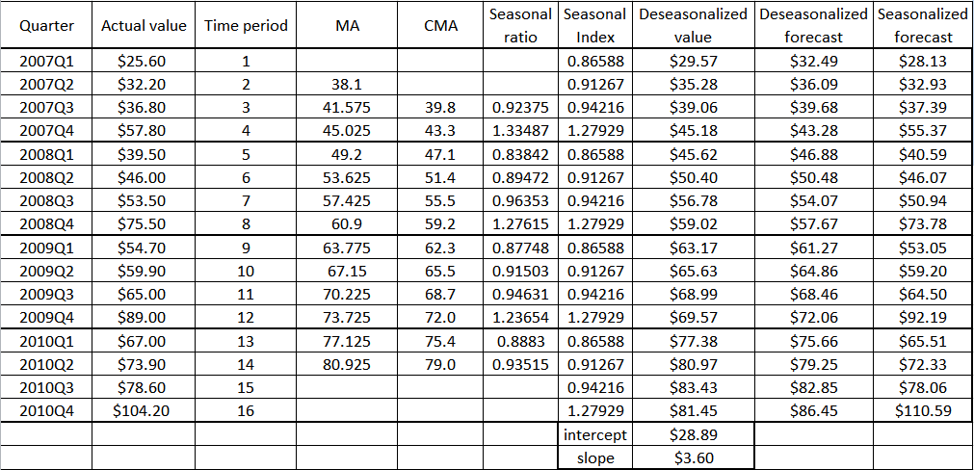

1. When do you use multiplicative decomposition method? When do you use additive decomposition method?
2. Do you always need to calculate CMA? When is it necessary to calculate CMA?
3. Based on slope = $3.60, intercept = $28.89 (slope and intercept of deseasonalized data), determine:

* The line equation used to calculate deseasonalized forecast. What method are you using to calculate the deseasonalized forecast?
* The deseasonalized forecast for 2011 Q4. What time series component(s) is(are) in the deseasonalized forecast?
* The seasonalized forecast for 2011 Q4. What time series component(s) is(are) in the seasonalized forecast?

**Question 3**

Given the following network, with the indicated flow capacities of each arc, determine the maximum flow from source node S to destination node C and the flow along each arc. Show your workings (the step by step procedure) clearly.

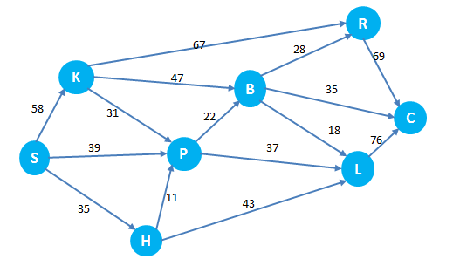

**Question 4**

A steel mill (node 1) supplies steel to manufactures in 6 other cities (node 2 to 7) via truck, as shown in the following network.

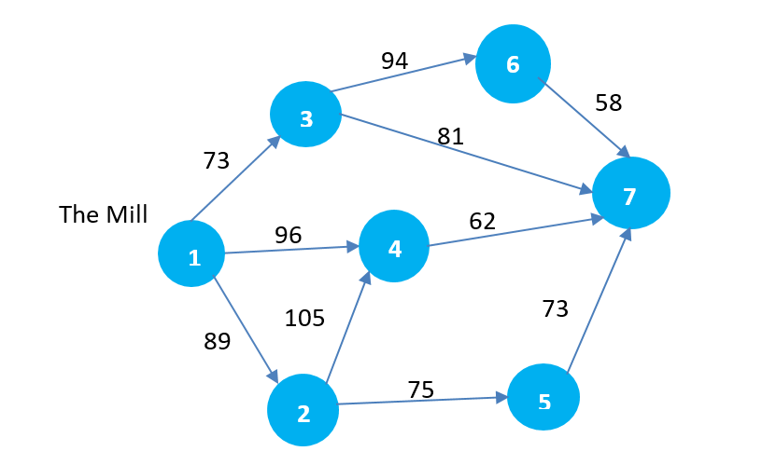

The travel time between cities, in hours, is shown along each arc. Determine the shortest path from the mill to each of the other 6 cities in the network. Show your workings (the step by step procedure) clearly.

**Question 5**

D&T has two manufacturing plants MP1 and MP2 to produce a newly developed product. The product is shipped to three retailers RS1, RS2 and RS3 directly or through two distribution centers DC1 and DC2. The distribution network available for shipping the product is illustrated in the following figure where the numbers on the arcs represent the unit shipping cost of the product.

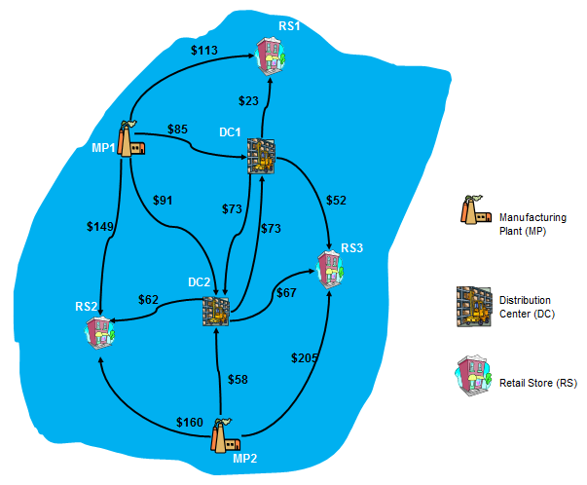

The supplies from the two plants are 400 (MP1) and 630 (MP2) units for this month, and the demands from the three retailers are 360 (RS1), 250 (RS2) and 260 (RS3) units. The distribution center 2 (DC2) also has a demand of 160 units in this month. In addition, the shipment cannot exceed 160 units from MP2 to DC2, and 130 units from MP1 to DC1. Help D&T to develop an optimal distribution plan with the lowest shipping cost.

1. Construct a network representation of the problem using the minimum cost flow model.
2. State the decision variables.
3. Write down the objective function.
4. Formulate the constraints.

**Question 6**

On a certain day, you need to formulate a plan to deliver a certain product (packed in boxes) from warehouse (O) to six customers (A, B, C,…F). The following table illustrates the distances (in km) between the warehouse and the 6 customers (A to F) and the demands from the 6 customers.

|  |  |  |  |  |  |  |  |  |
| --- | --- | --- | --- | --- | --- | --- | --- | --- |
|  | O | A | B | C | D | E | F | Demand |
| O | - | 31 | 19 | 35 | 33 | 34 | 36 | - |
| A | 31 | - | 13 | 21 | 23 | 6 | 11 | **16** |
| B | 19 | 13 | - | 24 | 26 | 25 | 21 | **38** |
| C | 35 | 21 | 24 | - | 15 | 18 | 32 | **20** |
| D | 33 | 23 | 26 | 15 | - | 25 | 15 | **33** |
| E | 34 | 6 | 25 | 18 | 25 | - | 18 | **27** |
| F | 36 | 11 | 21 | 32 | 15 | 18 | - | **42** |

1. Is this a routing or a scheduling problem? Explain.
2. Apply the Clarke & Wright Savings method to plan the delivery routes if the vehicles have a capacity of 200 boxes of the product.

|  |  |  |  |  |  |  |  |
| --- | --- | --- | --- | --- | --- | --- | --- |
| **Savings Table** | | | | | | | |
| **Sij** | **O** | **A** | **B** | **C** | **D** | **E** | **F** |
| **O** | 0 | 0 | 0 | 0 | 0 | 0 | 0 |
| **A** | 0 | 0 |  |  |  |  |  |
| **B** | 0 |  | 0 |  |  |  |  |
| **C** | 0 |  |  | 0 |  |  |  |
| **D** | 0 |  |  |  | 0 |  |  |
| **E** | 0 |  |  |  |  | 0 |  |
| **f** | 0 |  |  |  |  |  | 0 |

1. Complete the savings table above.
2. List down the savings rankings
3. Construct the route and state the corresponding rule you apply at each step.
4. What is the total distance traveled for the route derived from the Clark & Wright Savings method in question b)?
5. Apply the Clark & Wright Savings method to plan the delivery routes if the vehicles have a capacity of 100 boxes of the product.

**Question 7**

As an operations manager, Mr Lee needs to plan the amount of a certain product to produce according to a monthly forecast derived from the historical sales. Mr Lee has collected the following data for the past 12 months:

|  |  |
| --- | --- |
| Month | Sales for the product (kg) |
| 1 | 1025 |
| 2 | 1250 |
| 3 | 1115 |
| 4 | 955 |
| 5 | 1200 |
| 6 | 1350 |
| 7 | 1025 |
| 8 | 1250 |
| 9 | 1150 |
| 10 | 1350 |
| 11 | 1050 |
| 12 | 1150 |

**Show your workings** clearly and round off your answers to **two** decimal places for the following questions. Alpha = α.

1. Calculate the forecast for month 13 based on three-month and five-month moving average. How does the N in the N-period moving average method affect the forecast? Do you choose a three-month moving average or a five-month moving average if you want your forecast to be less responsive to the most recent sales data?
2. If trend is present in the historical sales data, how many periods does the 5-month moving average forecast lag?
3. Given the weights of 8, 5 and 2 for the most recent, next recent and most distant data, respectively, calculate the three-month weighted moving average forecast for month 13.
4. Given the simple exponential smoothing forecast for months 7 through 12, using Alpha (α) of 0.2 and 0.4, compute:
5. The forecast for month 13 using simple exponential smoothing with alpha (α) of 0.2
6. The forecast for month 13 using simple exponential smoothing with alpha (α) of 0.4
7. Which forecast is less responsive to the most recent sales data? Explain.
8. If trend is present in the historical sales data, how many periods does the forecast lag when the alpha (α) is 0.2?

|  |  |  |  |
| --- | --- | --- | --- |
| Month | Sales for the product (kg) | Exponential Smoothing  (Alpha = 0.2) | Exponential Smoothing  (Alpha = 0.4) |
| 7 | 1025 | 1136.69 | 1206.36 |
| 8 | 1250 | 1114.35 | 1133.82 |
| 9 | 1150 | 1141.48 | 1180.29 |
| 10 | 1350 | 1143.18 | 1168.17 |
| 11 | 1050 | 1184.55 | 1240.90 |
| 12 | 1150 | 1157.64 | 1164.54 |
| 13 |  | 1156.11???? | ?????? 1158.73 |

1. The table below shows the forecasting error calculated for some forecasting methods. Which forecasting method is the most accurate? Explain.

|  |  |  |  |
| --- | --- | --- | --- |
| **Forecasting methods** | **Measures of forecasting error** | | |
| MAD | MAPE | MSE |
| **MA (3-month)** | 136.67 | 11.74% | 24311.11 |
| **MA (5-month)** | 123.14 | 10.35% | 21404.86 |
| **Exp Smoothing, (alpha = 0.2)** | 128.30 | 10.99% | 22932.93 |
| **Exp Smoothing, (alpha = 0.4)** | 135.32 | 11.59% | 24796.61 |

**Question 8**

A researcher believes that a person’s self-confidence level (a rating between 0 and 100) is related to his/her weight. However, other researchers believe that other factors, such as educational background, personality, are stronger determinants of self-confidence level. The researcher collected some data shown in the table below.

**Show your workings** clearly and round off your answers to **two** decimal places.

|  |  |
| --- | --- |
| Self-confidence Level | Weight (kg) |
| 75 | 50 |
| 70 | 54 |
| 86 | 36 |
| 93 | 34 |
| 72 | 52 |
| 88 | 32 |
| 62 | 56 |
| 58 | 60 |
| 93 | 38 |
| 90 | 30 |
| 65 | 58 |
| 76 | 48 |
| 52 | 62 |
| 40 | 66 |
| 83 | 46 |
| 32 | 68 |
| 43 | 64 |
| 86 | 42 |
| 89 | 44 |
| 88 | 40 |

1. Identify the dependent variable y and the independent variable x in this case.
2. Determine the intercept and slopeand write down the linear equation.
3. Based on 5% level of significance, conclude whether the slope and intercept are significant in describing the relationship between the dependent and independent variable.
4. State the value of the correlation coefficient r and comment on the r value.
5. State the value of the coefficient of determination R-square and comment on the R-square value.
6. Predict the self-confidence level of a person if his weight is 45kg.